**JB Hi-Fi TV Products Insights**

**Overview**

This project delivers interactive and detailed insights into product performance across various TV products on the JB Hi-Fi platform, including analysis by brand, price range, customer ratings, promotions and free delivery options. The dashboard highlights key metrics such as the total number of products, average rating, total customer reviews, and category-specific trends, providing a comprehensive view of product performance.

The analysis is designed to help JB Hi-Fi understand customer preferences and market trends, enabling data-driven business decisions to optimize inventory, enhance customer satisfaction, and support strategic pricing and promotional efforts. The dataset was sourced through web scraping, including product names, prices, brand names, promotions, free delivery options, number of reviews, and ratings.

**Project Goal**

* Identify the most popular brand based on customer ratings and number of products.
* Determine the top-rated brand and products to highlight customer favorites.
* Categorize products into price groups and compare average ratings across these price ranges to evaluate if higher-priced items correlate with higher customer satisfaction.
* Track products with consistent availability and free delivery options, helping JB Hi-Fi prioritize stock management.
* Analyze products with the highest and lowest reviews to identify areas of strong and weak customer satisfaction.
* Explore the distribution of ratings to identify overall customer sentiment trends across products.
* Develop insights on price sensitivity by evaluating the relationship between product price and rating.
* Offer data-driven recommendations for adjusting promotional strategies and pricing to increase customer engagement.

**Data Transformation and Modelling**

The data from the dataset was organised into 4 separate tables to facilitate analysis:

* **Promo**: Contains the Promotion and Promotion ID.
* **Brand**: Contains the Brand name and Brand ID.
* **Size**: Contains the Size and Size ID.
* 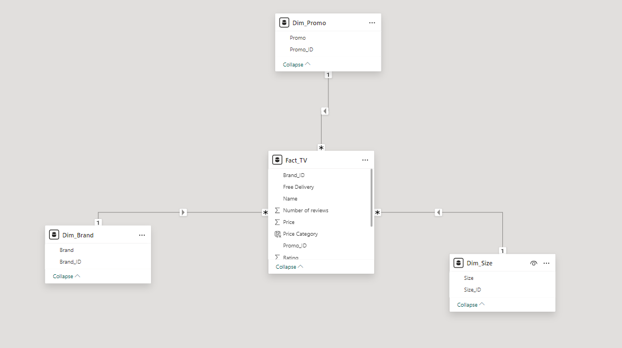**TV**: Contains the Brand ID, Free Delivery, Name, Number of reviews, Price, Promotion ID, Rating and Size ID.

**Dashboard Overview**

The JB Hi-Fi TV Product Dashboard provide a user-friendly interface and offer the following views:

**Executive Brand Overview Dashboard**

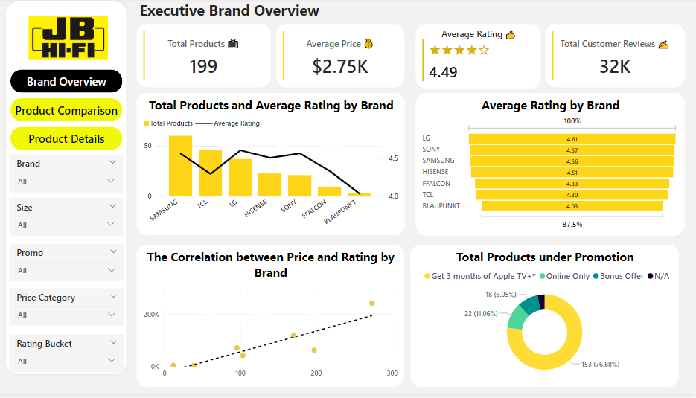

* **Total Products and Average Rating by Brand**: This chart uses yellow bars to display the number of products each brand offers, while a black line shows the average rating for those products. Samsung (60 products) and TCL (46 products) offer the highest number of products, but their average ratings vary, with Samsung slightly above 4.5 and TCL just 4.3. This dual-axis chart provides a quick overview of both the volume of products and the quality ratings for each brand, helping to identify popular brands with high customer satisfaction.
* **Average Rating by Brand**: This horizontal bar chart lists brands in descending order of average rating, with LG, Sony, and Samsung leading in customer satisfaction scores, all above 4.5. The visual allows for easy comparison of brand ratings, showing which brands are perceived most favorably by customers. Lower-rated brand like Blaupunkt has average ratings closer to 4, indicating room for improvement in customer satisfaction.
* **Total Products under Promotion**: Represented as a donut chart, this visualization categorizes products based on their promotional offers. A large majority (over 75%) of products belongs to “Get 3 months of Apple TV+”, while smaller segments show promotions such as "Online Only" (11.06%) and "Bonus Offer" (9.05%). This chart helps identify how promotional efforts are distributed and which types of offers are more common, providing insight into the company’s marketing strategy.
* **The Correlation between Price and Rating by Brand**: This scatter plot examines the relationship between product price and customer ratings for each brand, with each yellow dot representing a brand's product. The positive trend line suggests a slight correlation between higher prices and better ratings, implying that premium products may lead to higher customer satisfaction. This chart helps to explore if customers perceive higher-priced items as higher quality, which can inform pricing strategies.
* These charts collectively offer insights into JB Hi-Fi’s product variety, brand performance, customer preferences, and the effectiveness of promotional strategies. This dashboard can be valuable for strategic decisions related to product offerings, pricing, and promotions.

**Product Insights and Comparison**

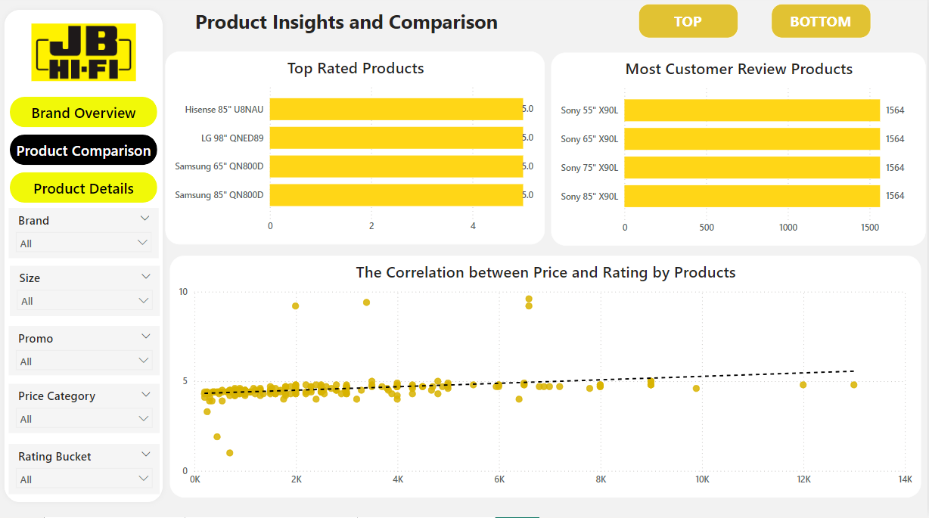

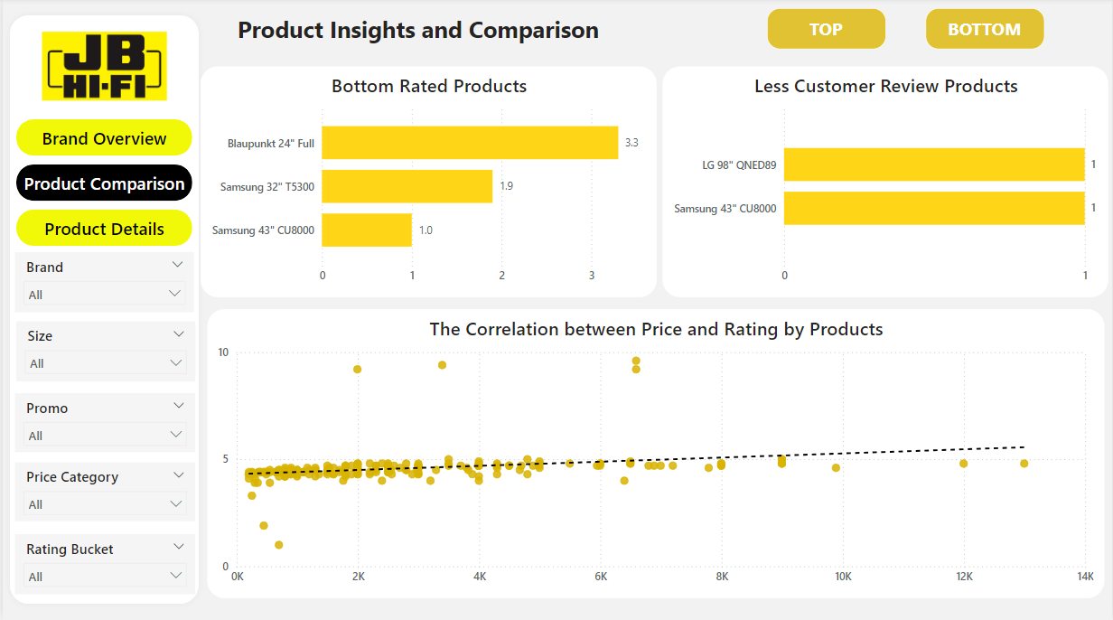

* **Top Rated Products**: This bar chart highlights the highest-rated products, with each product scoring a perfect 5.0 rating. Notably, Hisense, LG, and Samsung models dominate the top ratings, each receiving maximum customer approval.
* **Most Customer Review Products**: This bar chart shows products with the most customer reviews, with the Sony products receiving the highest number of reviews (1564 ratings).
* **Bottom Rated Products**: This chart illustrates the lowest-rated products, with Samsung 43” CU8000 receiving a low rating of 1, following by Samsung 32” T5300 (1.9). It highlights customer dissatisfaction with these particular models.
* **Less Customer Review Products**: This chart lists the products with the fewest reviews, where LG 98” QNED89 and Samsung 43” CU8000 have the lowest engagement, with 1 review each, showing limited customer feedback for these models.
* **Correlation between Price and Rating by Products**: This scatter plot displays a slight positive correlation between product price and rating. Although the trend line indicates an upward trend, the spread is wide, showing that higher prices do not consistently correlate with higher ratings.

**Product Details Dashboard**

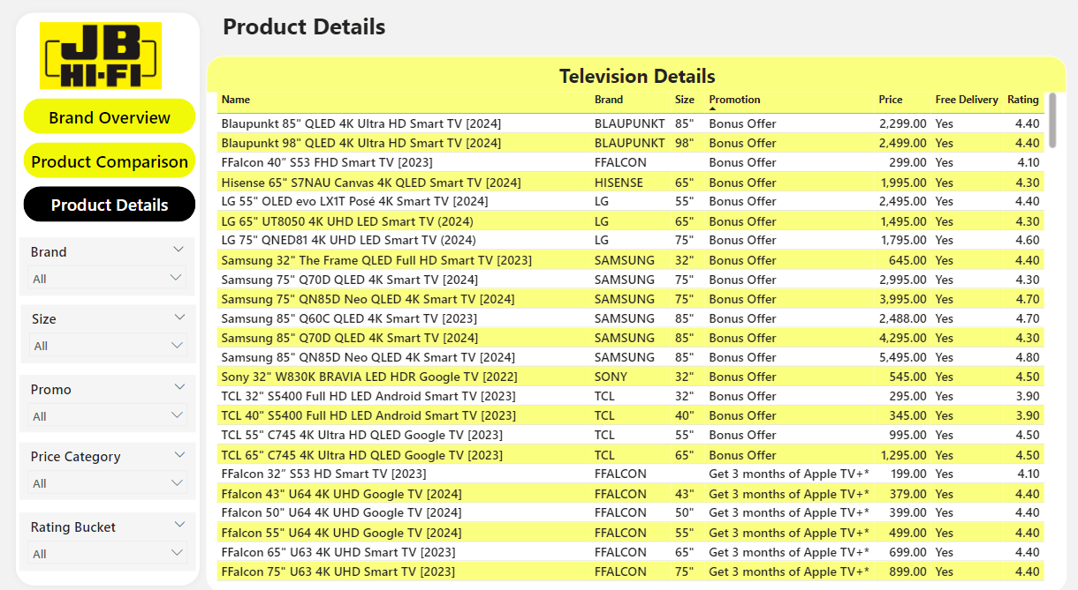

* This table provides detailed information on individual television models available at JB Hi-Fi, including fields such as name, brand, size, promotion, price, free delivery option, and customer rating. It offers a comprehensive view of each TV, showing varying prices, sizes, and ratings across different brands and models.

**Suggestions for the company**

* Enhance Product Range for High-Rated Brands: Brands like LG, Sony, and Samsung have high customer ratings, indicating strong customer satisfaction. JB Hi-Fi could consider expanding the product range for these popular brands to capitalize on their favourable perceptions. Increasing product availability for these brands may drive more sales and strengthen brand loyalty.
* Leverage Promotions to Boost Low-Performing Brands: Brands with lower average ratings, such as Blaupunkt, could benefit from targeted promotional strategies. JB Hi-Fi might introduce special offers (e.g., discounts, bundle deals) specifically for these brands to increase visibility, improve sales, and potentially attract new customers who may have been deterred by the lower ratings.
* Increase Marketing for High-Rated Products with Higher Price Points: The positive correlation between price and rating indicates that higher-priced items are generally well-received by customers. JB Hi-Fi could emphasize the quality and satisfaction of these higher-end products in their marketing campaigns. Highlighting positive reviews and satisfaction scores for premium products can help justify their price, attracting customers looking for quality.
* Evaluate and Adjust Promotion Strategy: JB Hi-Fi could analyze which promotions have the highest impact on sales and customer engagement, then consider expanding those types of offers. For example, creating more “Online Only” deals could appeal to digital shoppers and encourage online purchases.
* Optimize Inventory Based on Customer Preferences: Samsung and TCL have the highest number of products, but the ratings vary, with Samsung achieving a higher average rating. JB Hi-Fi might assess if the inventory mix aligns with customer demand and satisfaction. Reducing the stock of lower-rated products and reallocating resources to higher-rated products can improve inventory efficiency and customer satisfaction.
* Use Customer Ratings to Inform Product Development and Vendor Relations: For lower-rated brands, JB Hi-Fi could work with vendors to address quality issues or improve product features. Additionally, customer feedback from reviews could guide JB Hi-Fi in curating its product lineup, ensuring that new additions meet customer expectations.
* Regularly Monitor Rating Trends for Insights into Changing Preferences: Customer preferences and satisfaction may shift over time, so JB Hi-Fi should routinely review these metrics to identify emerging trends. Continuous monitoring will allow the company to adapt to changing customer needs, helping maintain high satisfaction and relevance in a competitive market.